CENWP-OD-B 06 July 2022

MEMORANDUM FOR THE RECORD

SUBJECT: 22BON031 CI LPS Lamprey Mortality

On 06 July, Bonneville Project Fisheries discovered one lamprey mortality in the Cascades Island LPS rest box #4. The fish was scanned for PIT tags, inspected, and returned to the river.

- Species – Pacific Lamprey (Entosphenus tridentatus)
- Origin – Unknown
- Length – Approximately 61 centimeters
- Marks and tags – None
- Marks and Injuries found on carcass – None
- Cause and Time of Death – Unknown
- Future and Preventative Measures – None
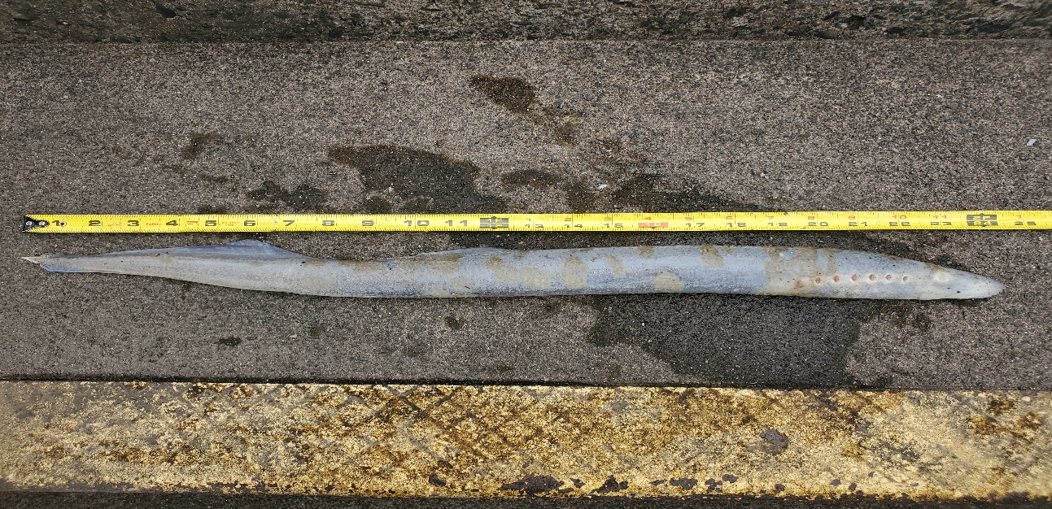

Sincerely,
Bonneville Project Fisheries

